ActiveMQ installation and Configuration - RH1

Schindler CRD Applications

Exported on 2025-08-19 05:06:42

Table of Contents

1 ActiveMQ Installation 3

2 OpenDJ Active Directory Update 6

3 Modify Info-Engine Administration. 10

4 Steps to configure SSL certificates: Dev Server 13

5 Send ActiveMQ Certificate to SAP – PI Team 18

6 Data Response Queue Creation 20

# ActiveMQ Installation

* ActiveMQ Installation ActiveMQ Installation OpenDJ Active Directory Update Modify Info-Engine Administration. Steps to configure SSL certificates: Dev Server Send ActiveMQ Certificate to SAP – PI Team Data Response Queue Creation
* OpenDJ Active Directory Update
* Modify Info-Engine Administration.
* Steps to configure SSL certificates: Dev Server
* Send ActiveMQ Certificate to SAP – PI Team
* Data Response Queue Creation
* Download Activemq 5.19.0

<https://activemq.apache.org/components/classic/download/classic-05-19-00>

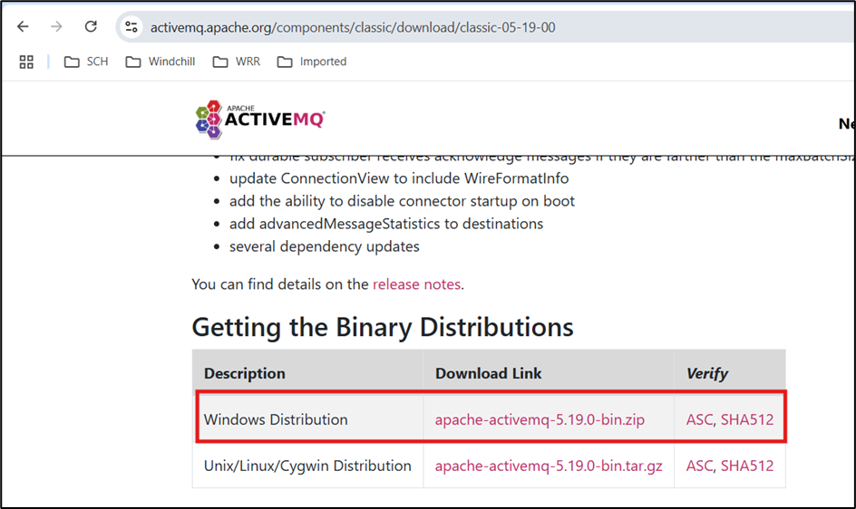

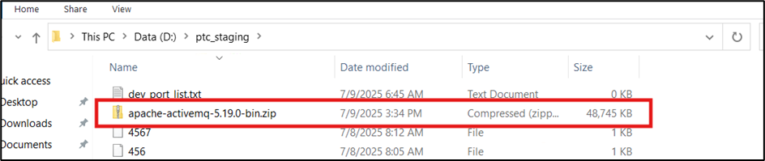

* Extract the downloaded folder in D:\ directory

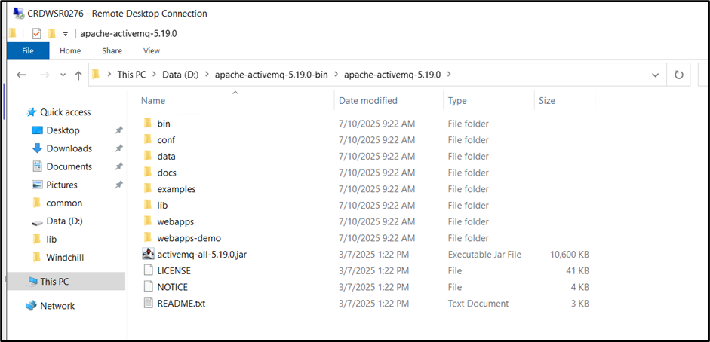

* Run as administrator the batch file D:\apache-activemq-5.19.0-bin\apache-activemq-5.19.0\bin\win64\InstallService. bat. This will install the ActiveMQ service

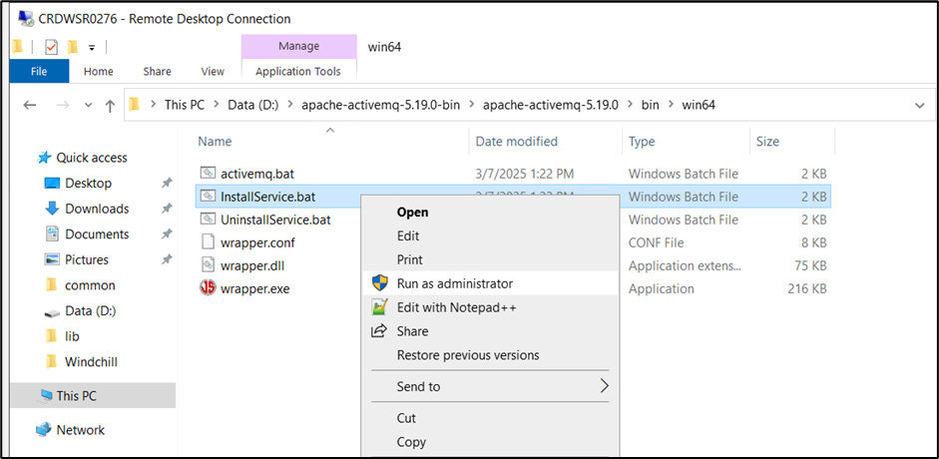

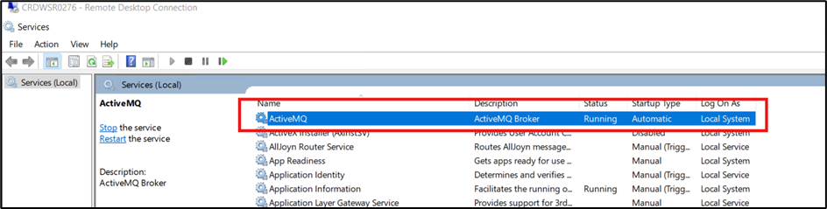

* Accessing activeMQ admin page

<http://127.0.0.1:8161/admin/queues.jsp>

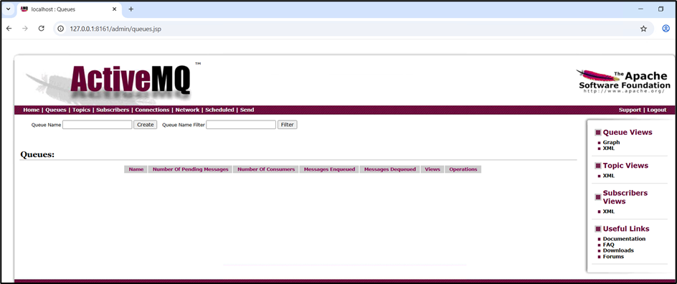

# OpenDJ Active Directory Update

* launch directory server

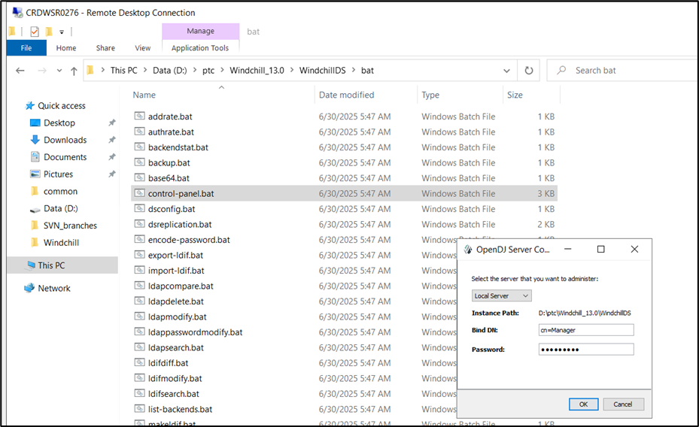

* Navigate to Mange entries and click Activemq and validate entries are correct as per server

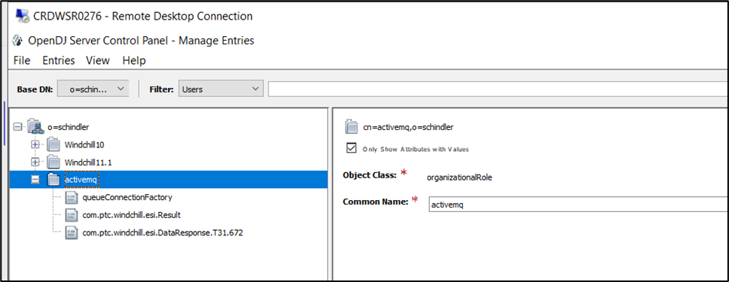

* Update javaReferenceAddress with correct host name

**Dev Server :** crdwsr0276

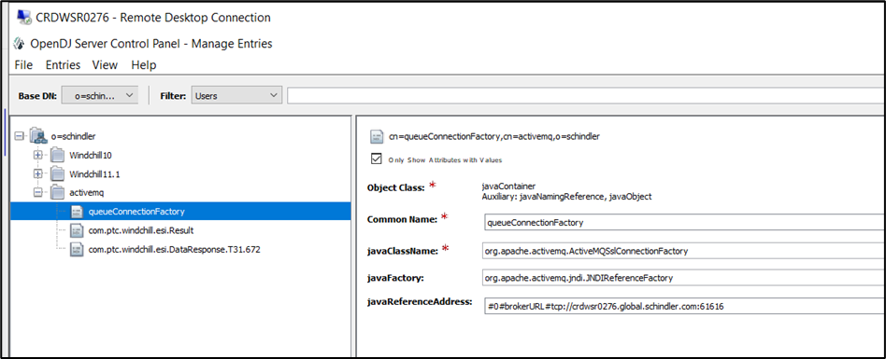

**QA Server :** crdwsr0279

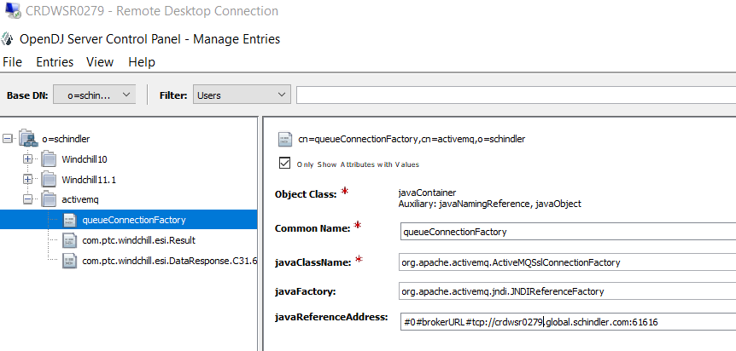

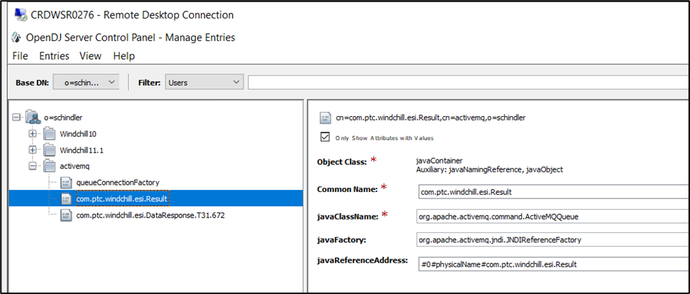

* Update Distribution target details

**Dev Server** – T31.672

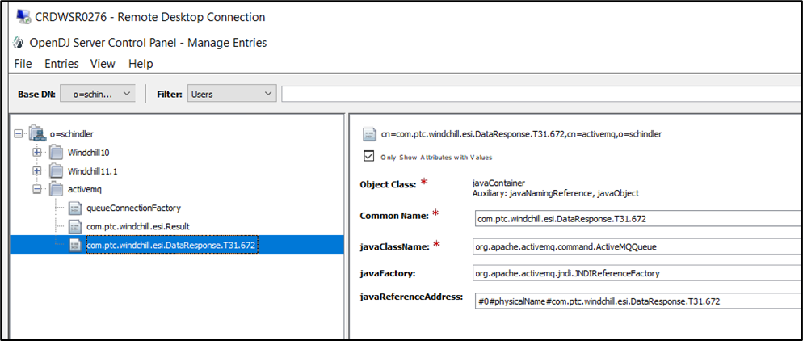

**QA Server** – C31.670

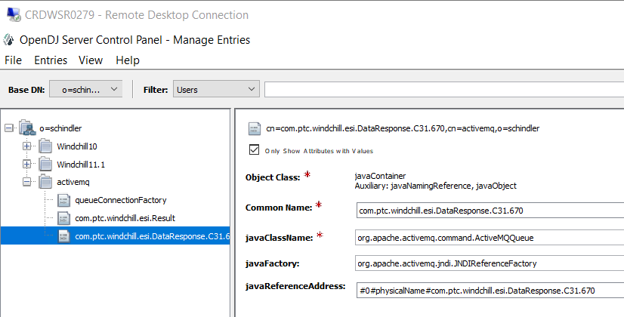

* Copy jar files from active MQ installation to Windchill/codebase/WEB-INF/lib folder.

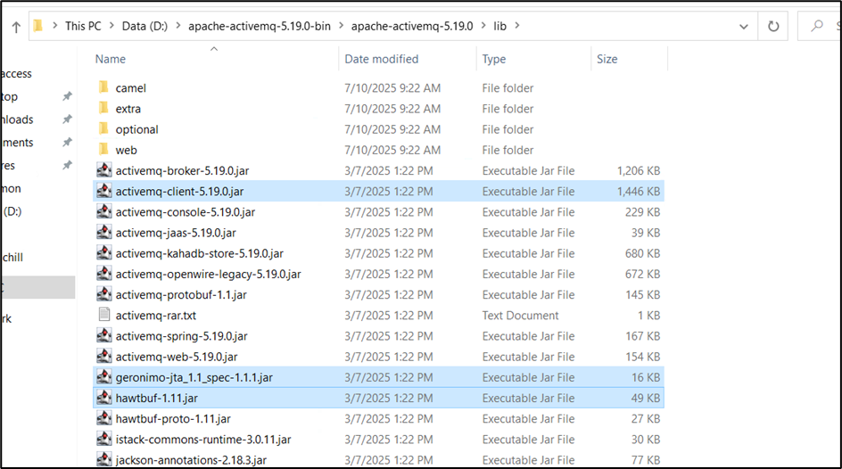

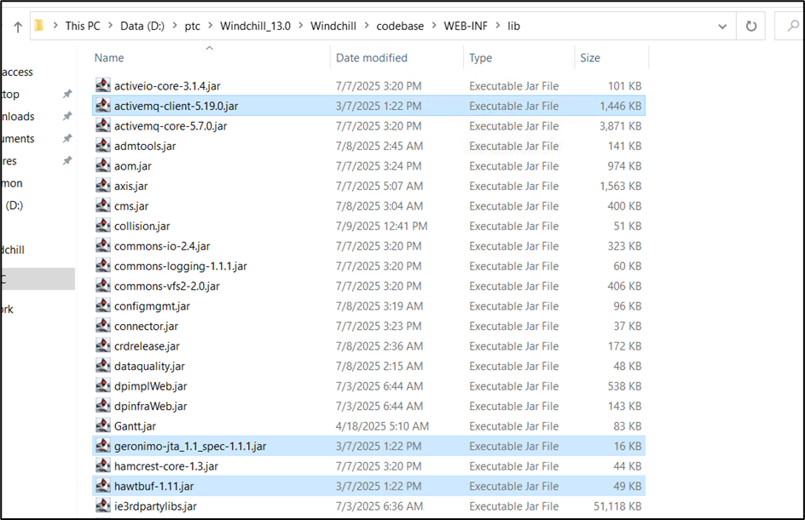

* Make sure below entry is available in performance.xconf and propagated. This will create ESIResult queue in ActiveMQ once windchill is started.

<!-- configure BackgroundMS to subscribe to ESI Result Queue -->  
 <Property name="wt.manager.cmd.BackgroundMS" overridable="true" targetFile="codebase/wt.properties" value="$(wt.manager.cmd.MethodServer) wt.method.serviceName={1} wt.queue.executeQueues=true wt.queue.queueGroup={5} wt.intersvrcom.sitePing=false wt.adapter.enabled=false wt.method.minPort=$([wt.method.bg](http://wt.method.bg).minPort) wt.method.maxPort=$([wt.method.bg](http://wt.method.bg).maxPort) wt.federation.task.startup=com/ptc/windchill/esi/SubscribeQueues.xml"/>

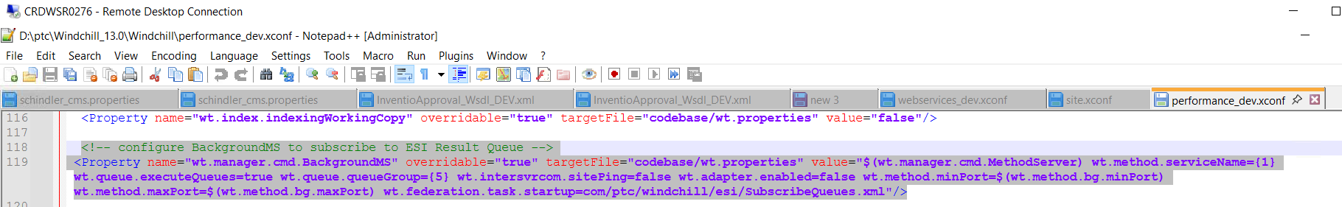



* Once Windchill is started then esi.Result queue will be created



# Modify Info-Engine Administration.

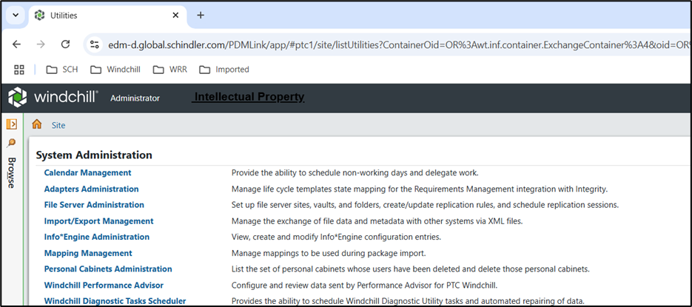

* For Dev Server Select com.schindler.global.edm-d.windchill adapter

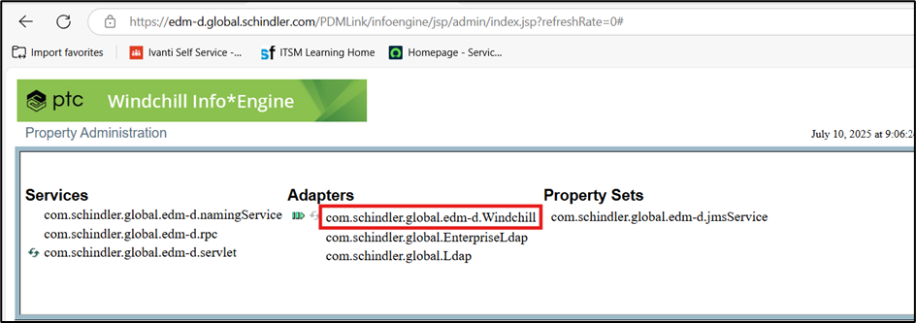

* For QA Server Select com.schindler.global.edm-d.windchill adapter
* Update Below details in adapter

**Dev Server**

JMS URI

<ldap://edm-d.global.schindler.com:389/cn=activemq,o=Schindler>

cn=Manager

cn=queueConnectionFactory

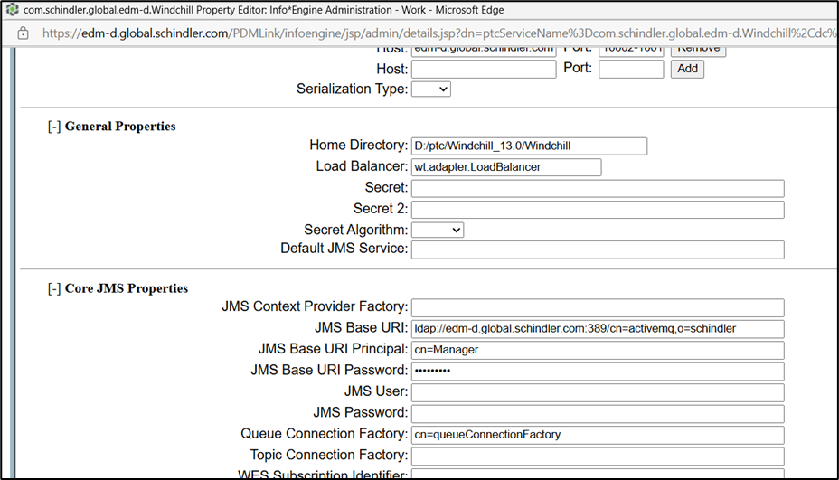

**QA Server**

JMS URI

[ldap://edm-q.global.schindler.com:389/cn=activemq,o=Schindler](ldap://edm-d.global.schindler.com:389/cn=activemq,o=Schindler)

cn=Manager

cn=queueConnectionFactory

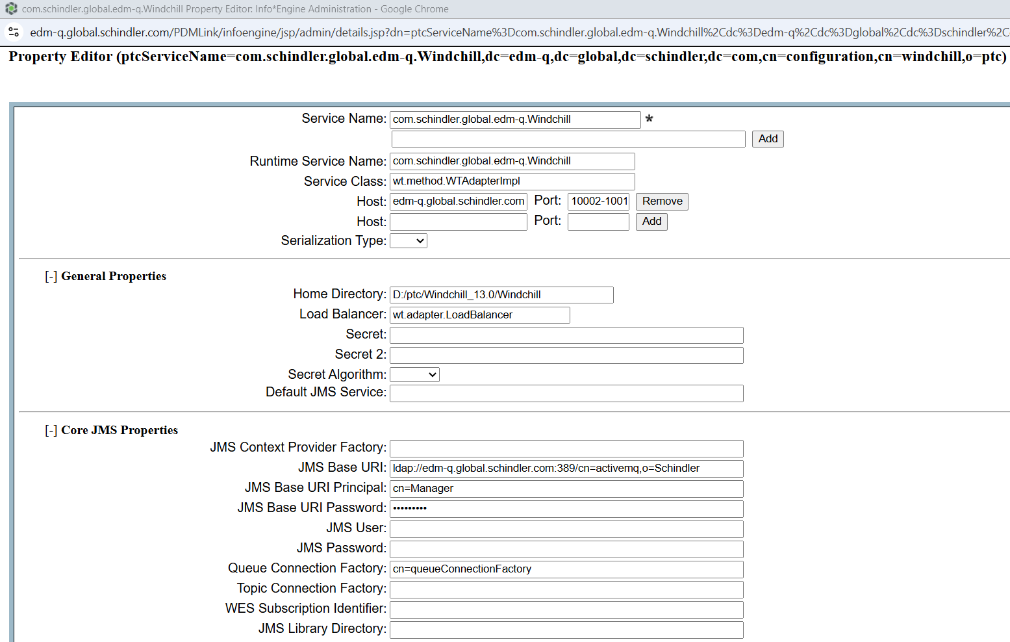

* Set below Preferences

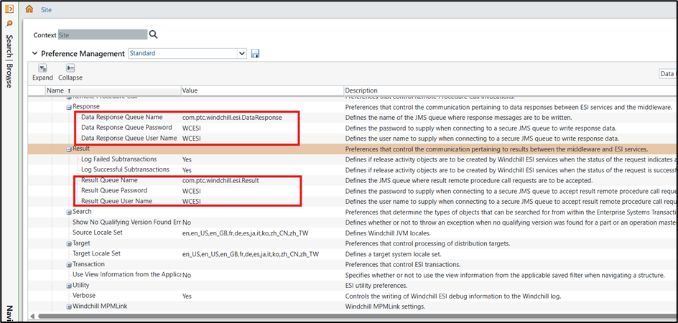

# Steps to configure SSL certificates: Dev Server

* Open cmd and navigate to **D:\apache-activemq-5.19.0-bin\apache-activemq-5.19.0\bin**



* Run below command to generate broker key. This will generate .ks file

***keytool -genkey -alias broker -keyalg RSA -validity 730 -keystore D:\apache-activemq-5.19.0-bin\ssl\amq_broker.ks***

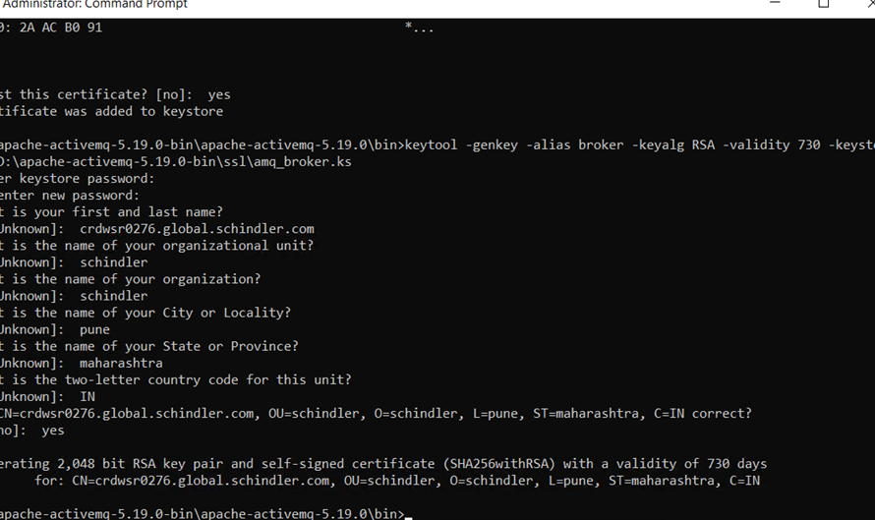



* Run below command to export the broker certificate. This will generate .cer file

***keytool -export -alias broker -keystore D:\apache-activemq-5.19.0-bin\ssl\amq_broker.ks -file D:\apache-activemq-5.19.0-bin\ssl\amq_broker_cert.cer***

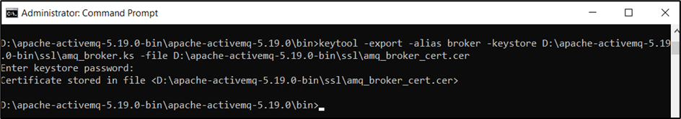

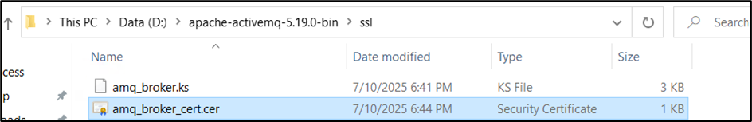

* Run below command from windchill shell. password is changeit. DevServerCrt is the alias which set during SSL configuration on windchill for server.crt file.

Dev Server:

***keytool -export -alias DevServerCrt -keystore D:\ptc\Windchill_13.0\Java\corretto\jdk17.0.11_9\lib\security\jssecacerts -file D:\apache-activemq-5.19.0-bin\ssl\client_cert***

QA Server:

***keytool -export -alias QAServerCrt -keystore D:\ptc\Windchill_13.0\Java\corretto\jdk17.0.11_9\lib\security\jssecacerts -file D:\apache-activemq-5.19.0-bin\ssl\client_cert***

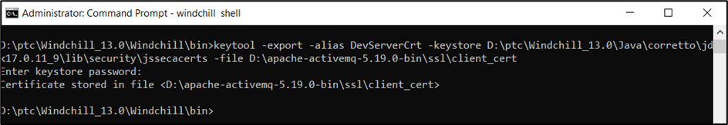

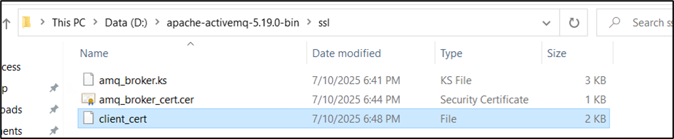

* Run below command to generate .ts file

***keytool -import -alias client -keystore D:\apache-activemq-5.19.0-bin\ssl\amq_broker.ts -file D:\apache-activemq-5.19.0-bin\ssl\client_cert***

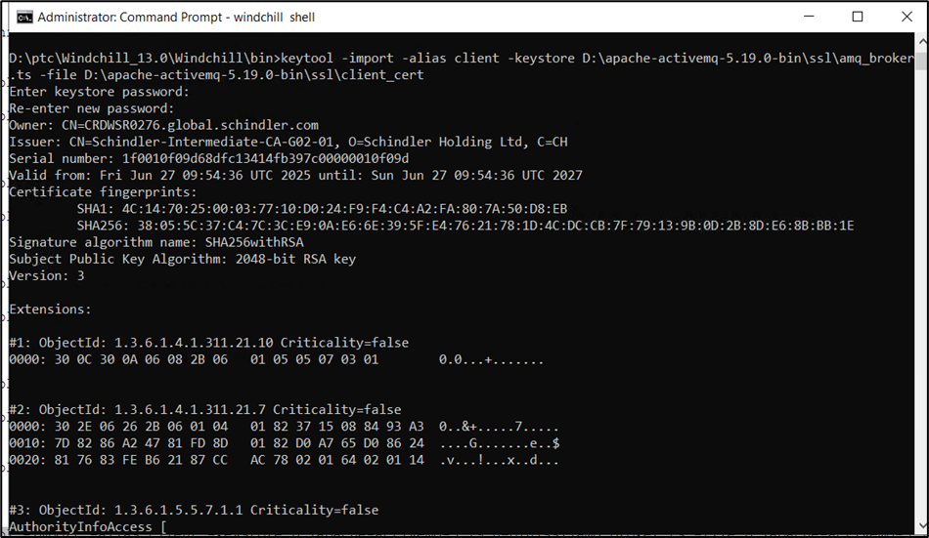

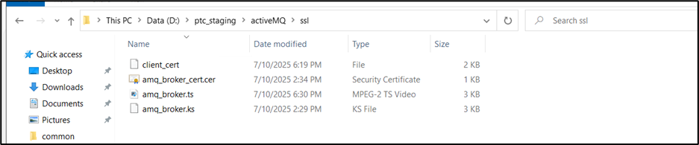

* Run below command to delete existing alias broker if any

***keytool -delete -keystore D:\ptc\Windchill_13.0\Java\corretto\jdk17.0.11_9\lib\security\jssecacerts -alias broker***

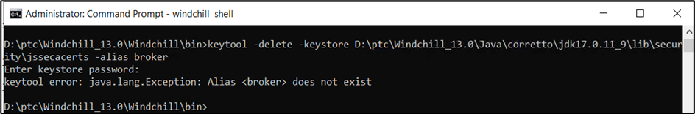

* Run below command to import broker certificate

***keytool -import -alias broker -file D:\apache-activemq-5.19.0-bin\ssl\amq_broker_cert.cer -storetype JKS -keystore D:\ptc\Windchill_13.0\Java\corretto\jdk17.0.11_9\lib\security\jssecacerts -storepass changeit***

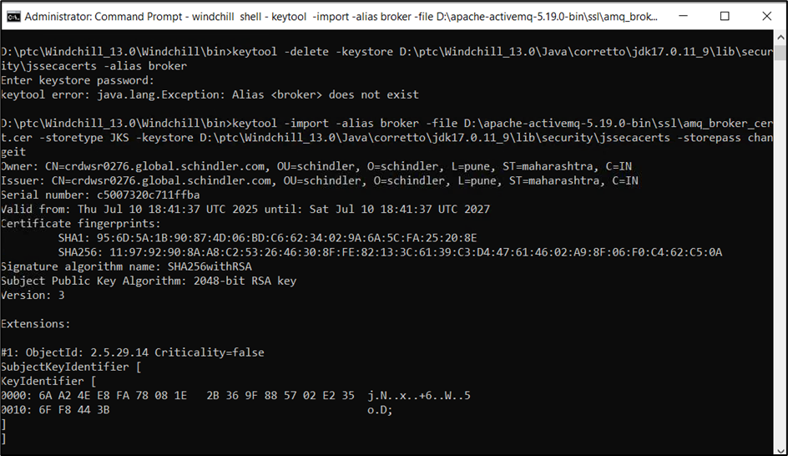

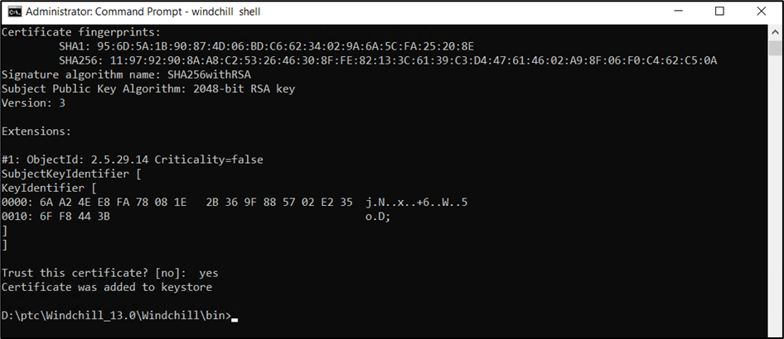

* copy D:\apache-activemq-5.19.0-bin\ssl\amq_broker.ts and D:\apache-activemq-5.19.0-bin\ssl\amq_broker.ks files to D:\apache-activemq-5.19.0-bin\apache-activemq-5.19.0\conf folder

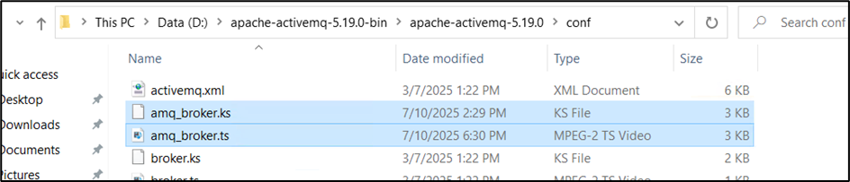

* Add below entries in   
  D:\apache-activemq-5.19.0-bin\apache-activemq-5.19.0\conf\activemq.xml

**<sslContext keyStore="file:${activemq.base}/conf/amq_broker.ks" keyStorePassword="changeit" trustStore="file:${activemq.base}/conf/amq_broker.ts" trustStorePassword="changeit" />**

**</sslContext>**

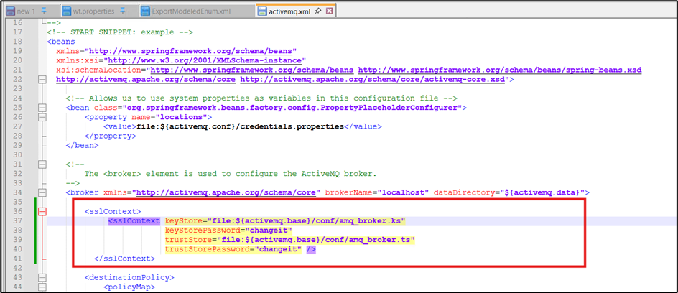

**<transportConnector name="openwire" uri="****tcp://0.0.0.0:61616?maximumConnections=1000&amp;wireFormat.maxFrameSize=104857600"/****>**

**<transportConnector name="amqp+ssl" uri="amqp+****ssl://0.0.0.0:5671?maximumConnections=1000&amp;wireFormat.maxFrameSize=104857600&amp;transport.transformer=jms"/****>**

**<transportConnector name="ssl" uri="****ssl://0.0.0.0:61617?maximumConnections=1000&amp;wireFormat.maxFrameSize=104857600&amp;transport.transformer=jms"/****>**

**<transportConnector name="stomp" uri="****stomp://0.0.0.0:61613?maximumConnections=1000&amp;wireFormat.maxFrameSize=104857600"/****>**

**<transportConnector name="mqtt" uri="****mqtt://0.0.0.0:1883?maximumConnections=1000&amp;wireFormat.maxFrameSize=104857600"/****>**

**<transportConnector name="ws" uri="****ws://0.0.0.0:61614?maximumConnections=1000&amp;wireFormat.maxFrameSize=104857600"/****>**

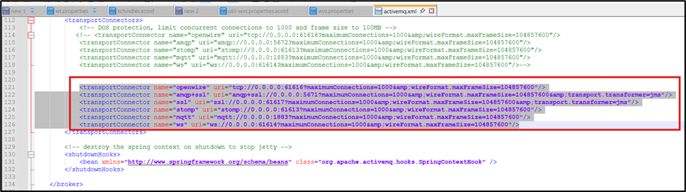

* Restart ActiveMQ Service

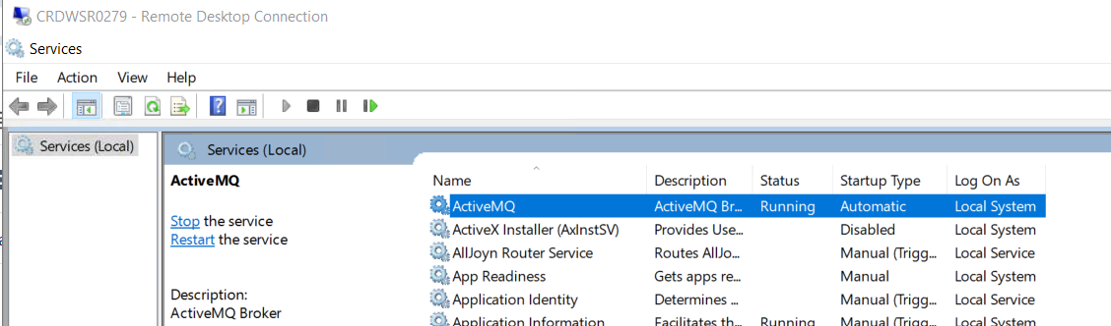

* Run netstat -ano command from cmd and make sure ActiveMQ Service is listening to port 5671

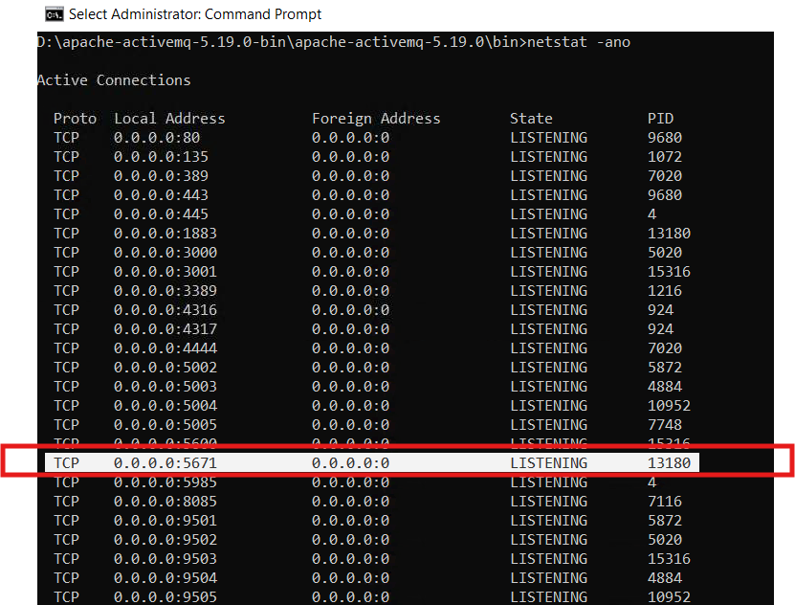

* Take restart if HTTP, DS and Windchill by clearing cache.

# Send ActiveMQ Certificate to SAP – PI Team

* Open cmd and navigate to D:\apache-activemq-5.19.0-bin\apache-activemq-5.19.0\bin
* Run below command to export the certificate. Enter password changeit

keytool -export -alias broker -keystore D:\apache-activemq-5.19.0-bin\ssl\amq_broker.ks -file D:\apache-activemq-5.19.0-bin\ssl\amq_broker_cert.cer

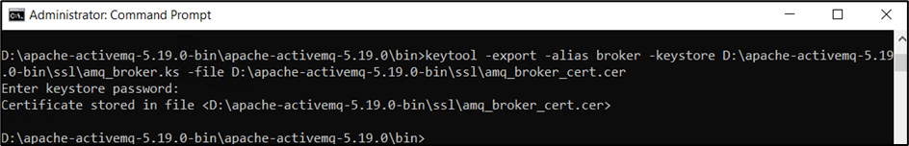

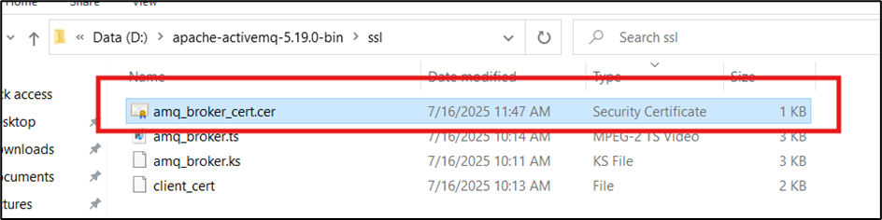

* Click on .cer file and validate start and end date of certificate. End date should be more than 2 years

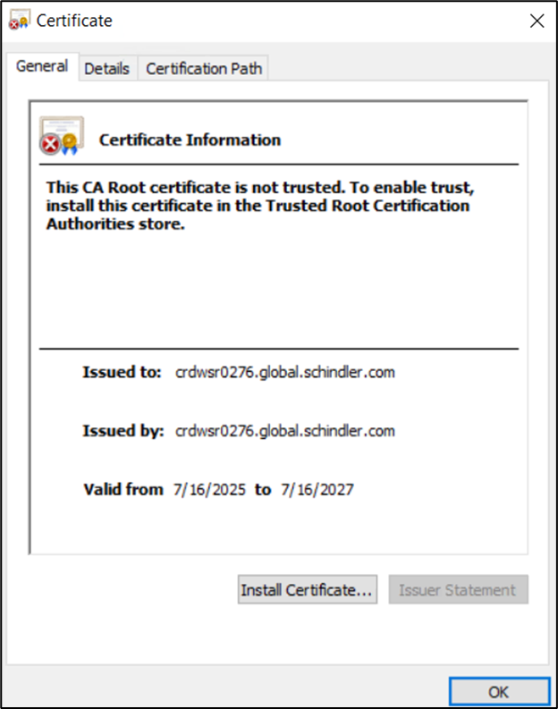

* Once SAP PI and ActiveMQ connection is setup, Connection should be successful from SAP PI to ActiveMQ. Refer below snapshot from SAP PI connector.

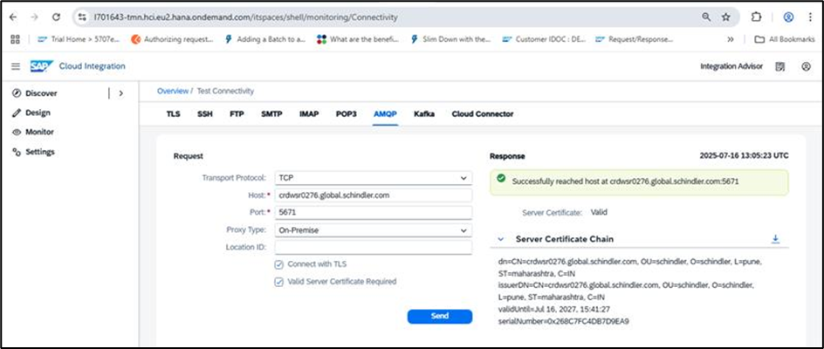

# Data Response Queue Creation

* DataResponse Queue will be created once we create KA in windchill with EDM-PDM attribute Yes.

